1. We created the true underlying data to study the concepts of applying logit and probit regressions using the below equation:

Logit(pi) = -1.2 +5x1i -0.4x2i

The probability of y|x was calculated using the inverse logit and then true values of y were obtained using rbinom for each probability of y. Therefore 500 observations of 1 and 0 were calculated and then a glm model was run using probit and logit regression. Please find below the two summaries:

Model summary using Probit:

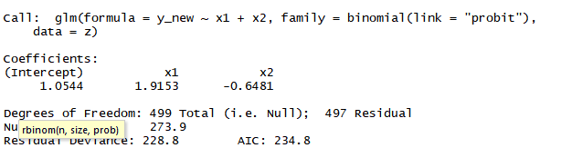

Model summary using Logit

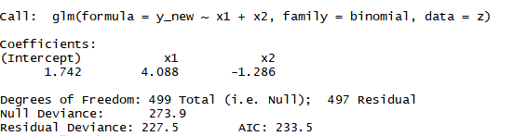

1. We created the true underlying data to study the concepts of applying logit and probit regressions using the below equation:

Φ-1 (pi)== -1.2 +5x1i -0.4x2i

The probability of y|x was calculated using the inverse logit and then true values of y were obtained using rbinom for each probability of y. Therefore 500 observations of 1 and 0 were calculated and then a glm model was run using probit and logit regression. Please find below the two summaries:

Model summary using Probit:

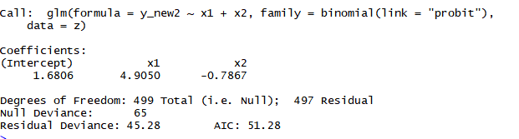

Model summary using Logit

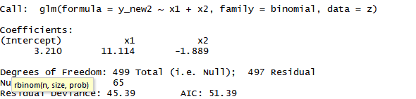

Executive Summary

1. We created the true underlying data to study the concepts of applying logit and probit regressions using the below equation:

Logit(pi) = -1.2 +5x1i -0.4x2i

We observed that when the underlying data is distributed in binomial classification as in logit transformation than logit regression results into accurately predicting the coefficients as compared to probit regression.

1. We created the true underlying data to study the concepts of applying logit and probit regressions using the below equation:

Φ-1 (pi)== -1.2 +5x1i -0.4x2i

We observed that when the underlying data is distributed in normal distribution as in the case of latent variable in probit transformation than probit regression results into accurately predicting the coefficients as compared to logit regression.